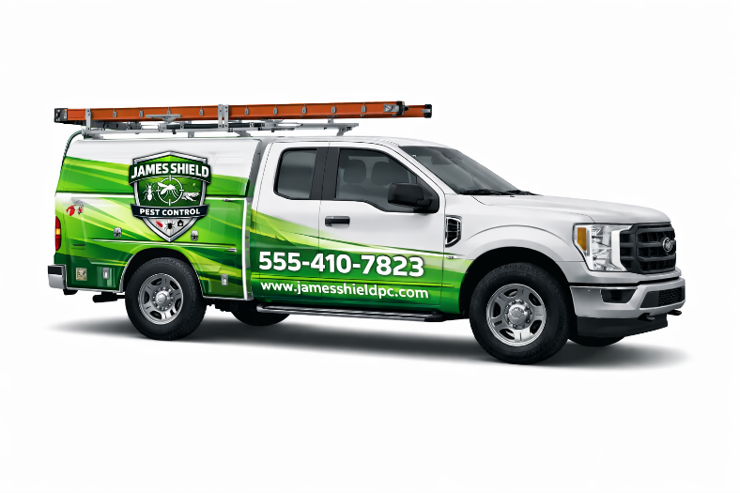
James Shield Pest Control
Company Vehicle and Work Driving Policy
Purpose:
This policy outlines the requirements for employees who operate company-owned, leased, or rented vehicles, or who drive personal vehicles for company business. The purpose is to promote safety, legal compliance, and responsible use of company vehicles.
Authorized Use:
- Company vehicles are for business use only.
- Personal or after-hours use of company vehicles is strictly prohibited unless prior written approval is granted by management.
- Company vehicles may only be operated during scheduled work hours and for assigned job duties.
- Vehicles may not be driven by unauthorized individuals.
Licensing and MVR Requirements:
- Employees must maintain a valid driver’s license appropriate for the vehicle being operated at all times.
- Employees must immediately notify management of any license suspension, revocation, restriction, or expiration.
- A satisfactory Motor Vehicle Record (MVR) is required at all times.
- The company reserves the right to conduct MVR checks at hire and periodically thereafter.
- Failure to meet licensing or MVR requirements may result in loss of driving privileges and disciplinary action.
Substance Use:
- Operating a company vehicle or driving on company business under the influence of alcohol, illegal drugs, marijuana, or any impairing substance is strictly prohibited.
- This includes prescription or over-the-counter medications that impair the ability to drive safely.
- Possession or consumption of alcohol or illegal substances in company vehicles is prohibited at all times.
Safe Driving Expectations:
Employees must:
- Comply with all traffic laws and posted speed limits.
- Wear seat belts at all times and ensure passengers do the same.
- Drive defensively and operate vehicles in a safe and courteous manner.
- Avoid distracted driving, including the use of handheld mobile devices.
- Never engage in reckless or unsafe driving behaviors.
Accidents and Violations:
- All accidents, incidents, and vehicle damage must be reported to management immediately.
- All traffic citations received while driving on company business must be reported promptly.
Policy Enforcement:
Failure to comply with this policy may result in disciplinary action, up to and including loss of driving privileges or termination of employment.
Acknowledgment:
Employees authorized to drive on behalf of the company are required to understand and comply with this policy as a condition of employment.

